

ITCS486 Multimedia Data Technologies

Unity 3D Game Project

Arena of Duelist

Submitted by

Pornthipa Khummalai Section 2 ID:6088066

Apichaya Kuama Section 2 ID:6088097

Tanatip Tumsatiansuk Section 2 ID:6088172

Instructor

Dr. Pisit Praiwattana

A report is submitted in partial fulfillment of the requirements for

ITCS486 Multimedia Data Technologies

Faculty of Information and Communication Technology

Mahidol University

**Arena of duelist 3D game (Jam-3H)**

The swat accidentally gets lost in the prisoner’s bunker. The only way to survive is to fight. There are not only people in the prison that you have to kill, but also all of the monsters. Before moving forward make sure that your weapon is ready to use with a bullet otherwise you will get killed.

**HOW TO PLAY:**

• Control the player by pressing WASD.

• Jump by passing Space bar.

• Run by passing Left shift.

• Crouch by passing Left Ctrl.

• Attack the enemy by using mouse click.

* Using right click to aim.
* Using left click to fire the gun and weapon.

• Walking through the object on the floor in order to pick up weapons and med kit.

• Choosing and changing the weapon by passing TAP and select the weapons to use by using mouse click on the weapon.

• Dropping the weapon by passing F.

• Split- screen by passing C.

• Pause the game by passing Escape.

**REQUIREMENT:**

* Option to have Split-screen localgame, the default should be single-player
* Maximum size of 100x100 bounded in Unityunits
* Allow 3 types of melee weapons to be pick-up then equipped or throwing off-hand to rest on the floor
* Allow 3 types of projectile weapon(Physical-basedisacceptable)with similar behaviour to melee item
* Projectile has limited ammo so it must show on the HUD, when ammo is out, it is being destroyed
* Enemy to attack player by any of your design mechanics – This enemy should seek player or has aggorange
* Button to trigger player attack(Depending on whatever player is holding)
* Score of the player on the HUD
* Winning Conditions of your own >> Kill another in PVP match
* Winning or losing message on GUI upon ending the session
* Health System is required
* Player is required to have a simple primitive model to represent its shape during session

Game demo video link: <https://www.youtube.com/watch?v=He90CwT02hg>

GoogleDrive:<https://drive.google.com/drive/u/0/folders/1QDh4fdtKJEgDwI2Dfo5E2hISoPTsMHsN>

GitHub: <https://github.com/Nonggun/MMDtech/tree/b-prj2020-A1-Mr.-Gun/asset/Rsc_Mr.Gun/3D%20Arena%20of%20Duelist%20game>

**REQUIREMENT:**

**Checkpoint 1:** Option to have Split-screen localgame, the default should be single-player.

* + Split- screen by pass C
  + Single-player

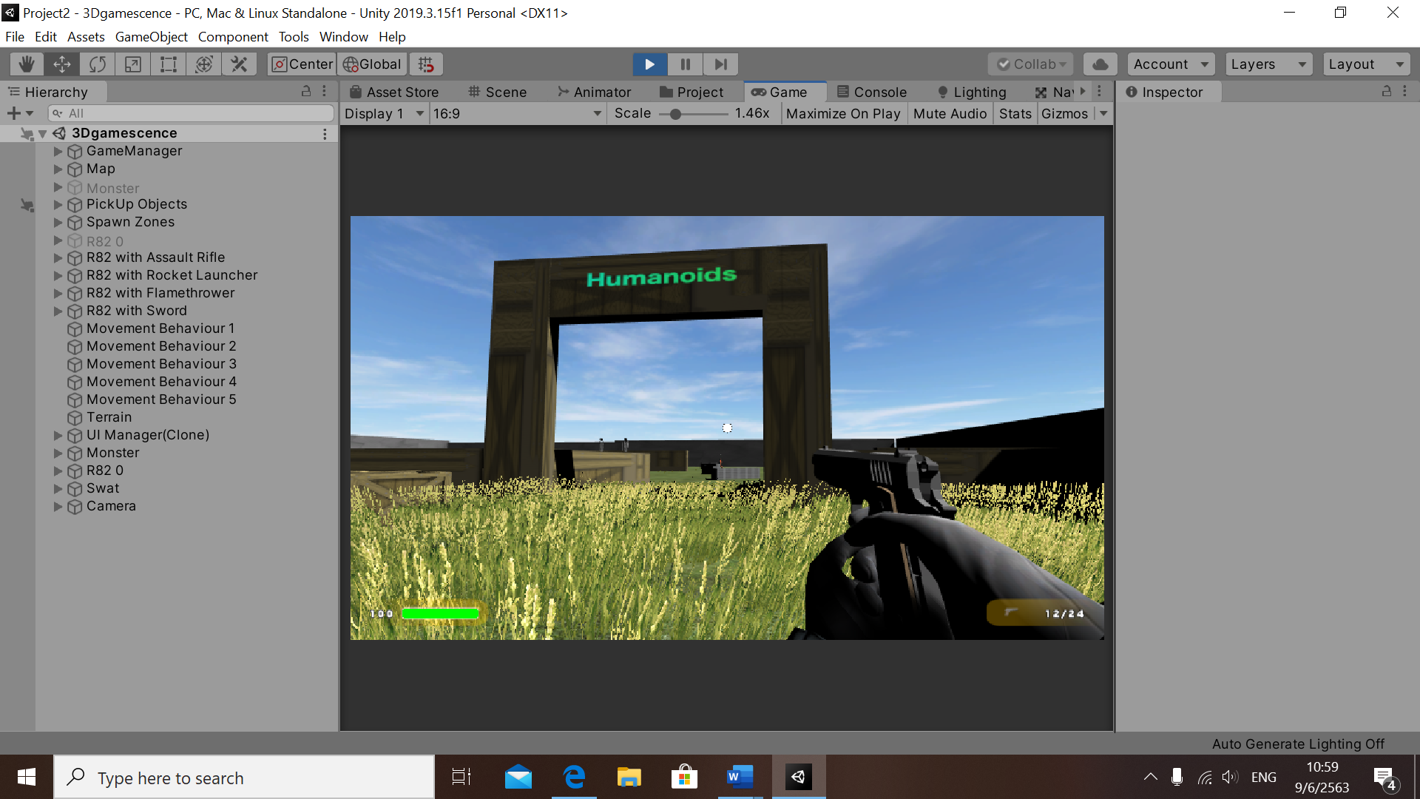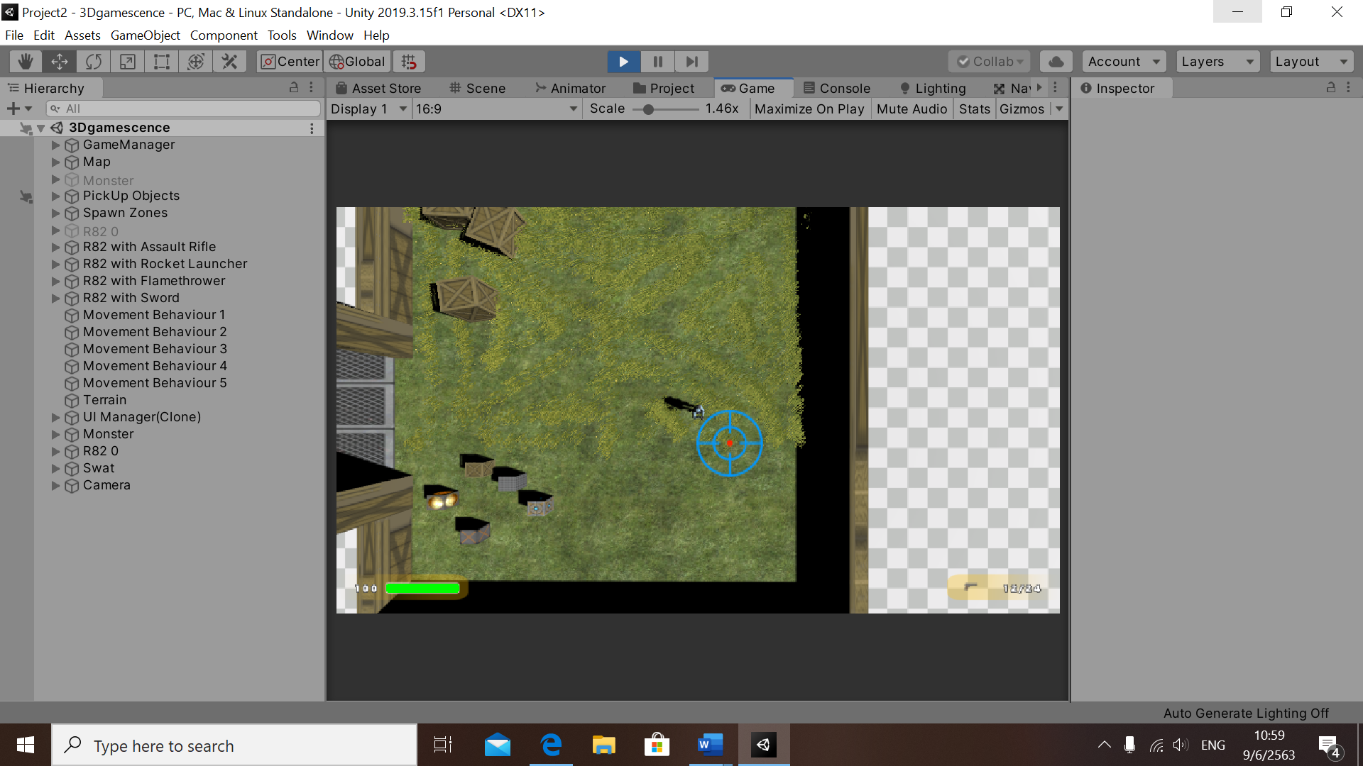

**Checkpoint 2:** Maximum size of 100x100 bounded in Unityunits.

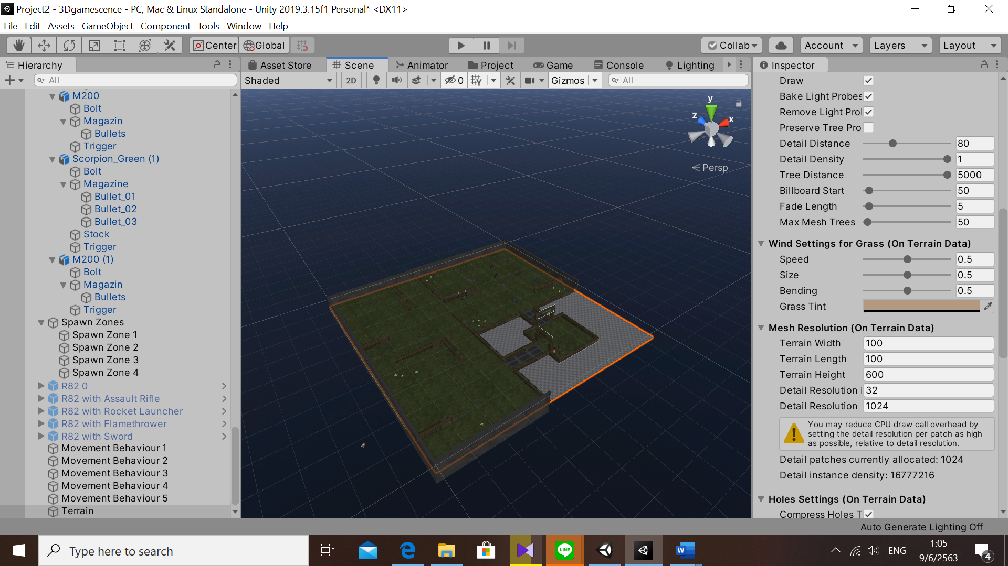

**Checkpoint 3:** Allow 3 types of melee weapons to be pick-up then equipped or throwing off-hand to rest on the floor.

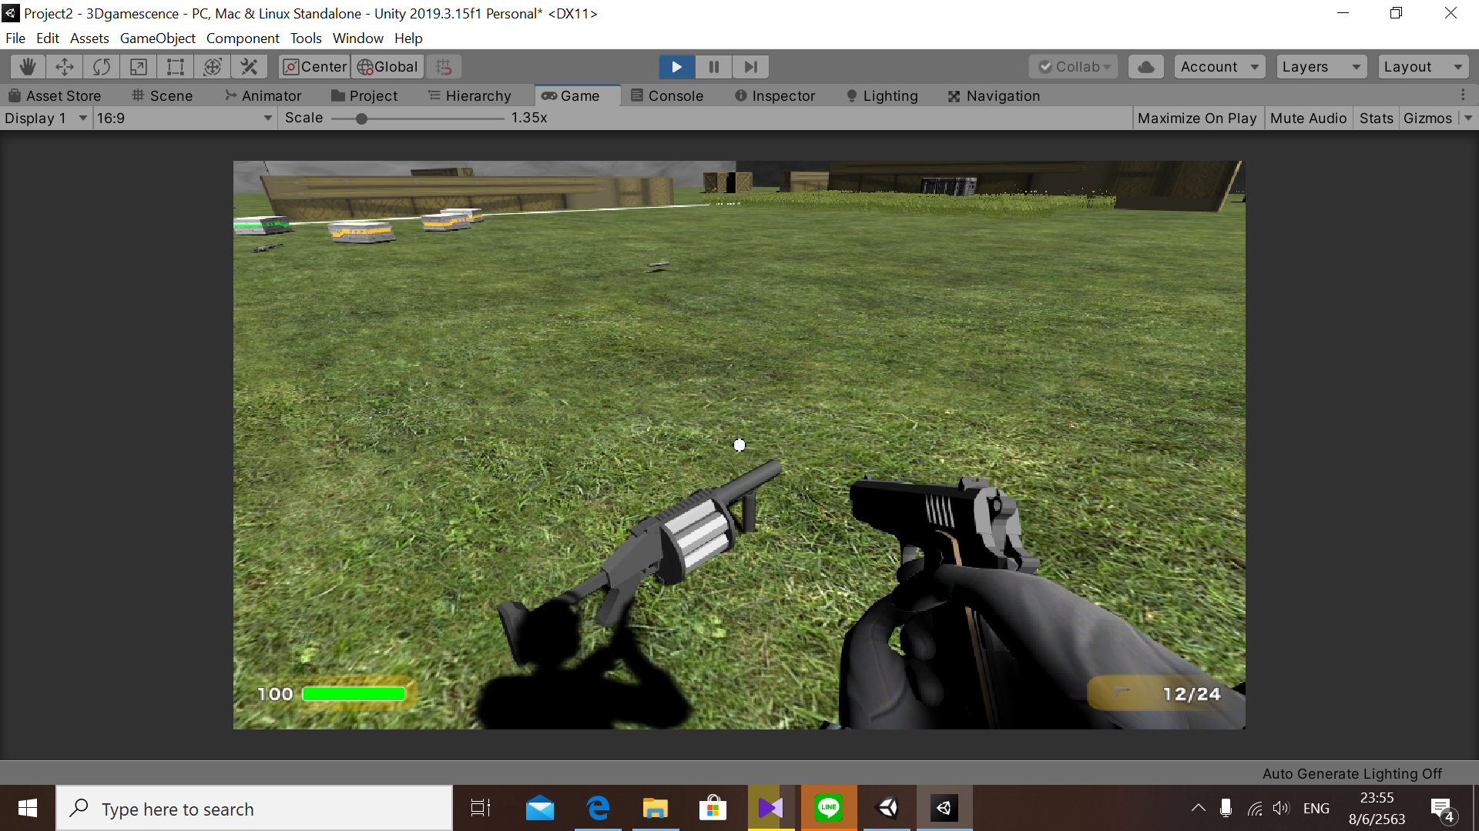

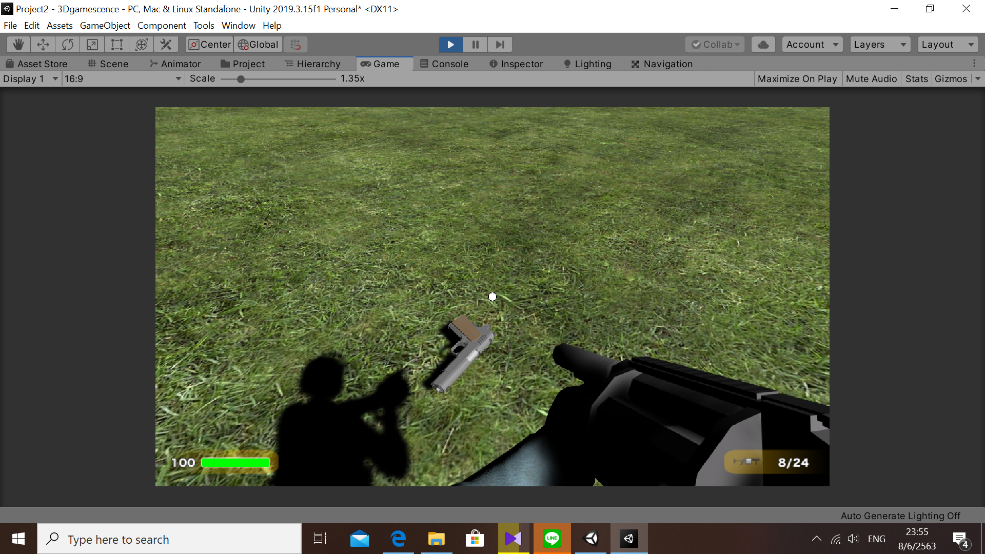

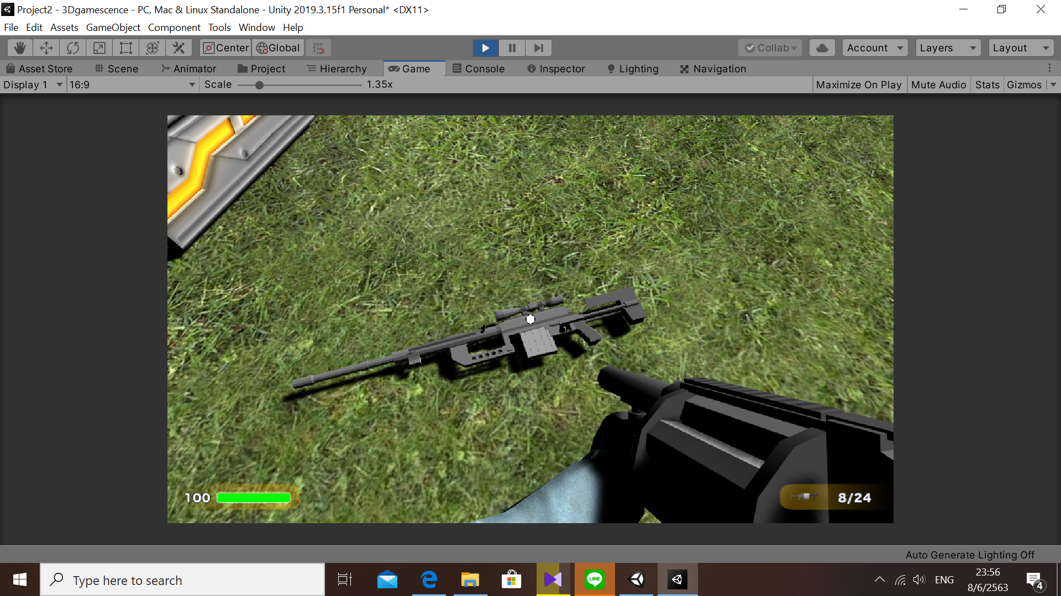

**Checkpoint 4:** Allow 3 types of projectile weapon(Physical-basedisacceptable)with similar behavior to melee item.

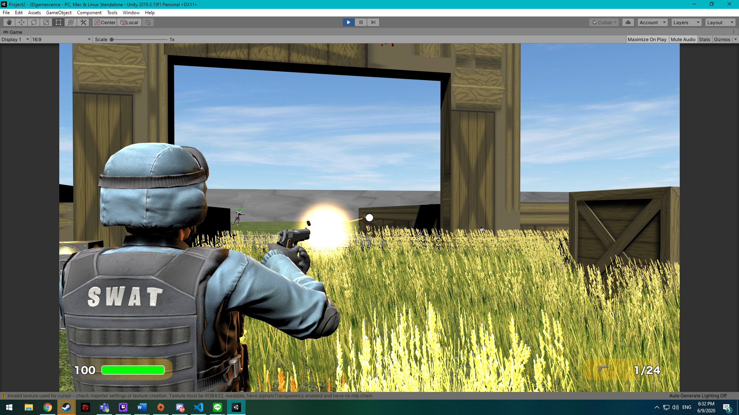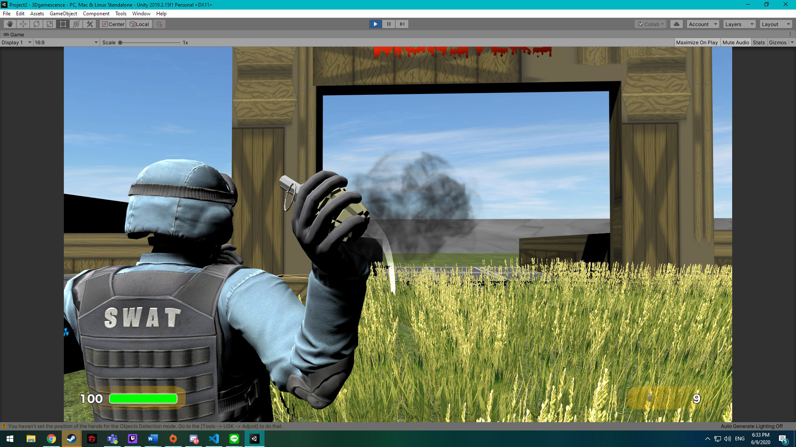

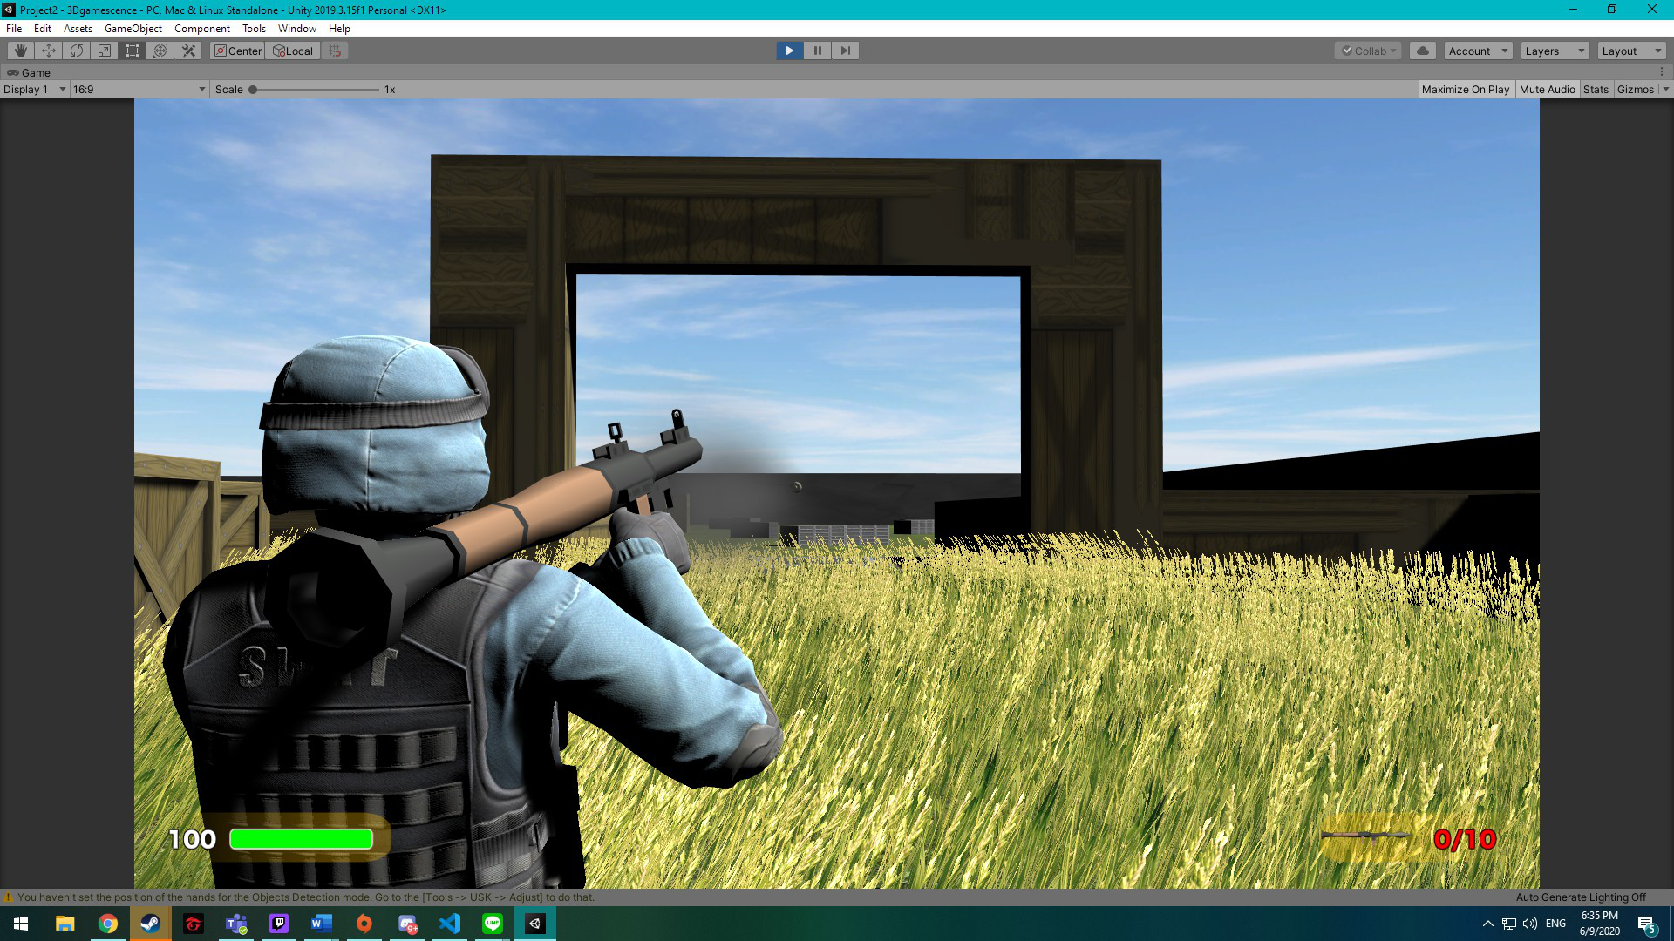

**Checkpoint 5**: Projectile has limited ammo so it must show on the HUD, when ammo is out, it is being destroyed

* + **Before**  
  + **After**

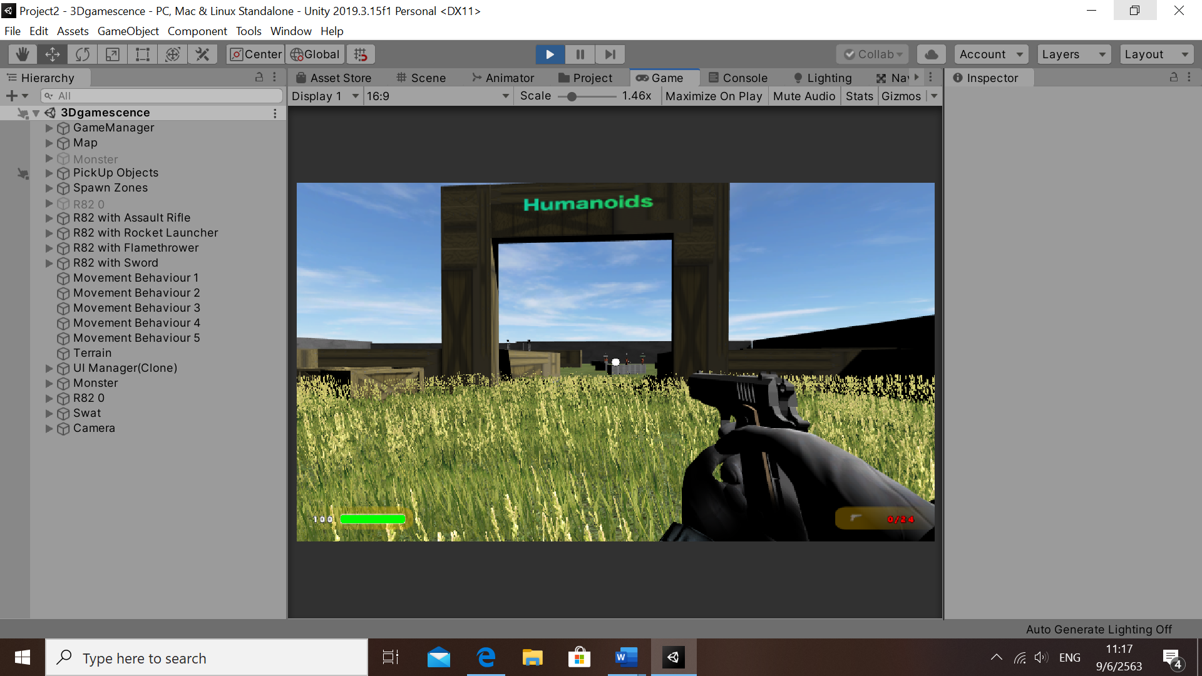

**Inventory**

* + **Before**

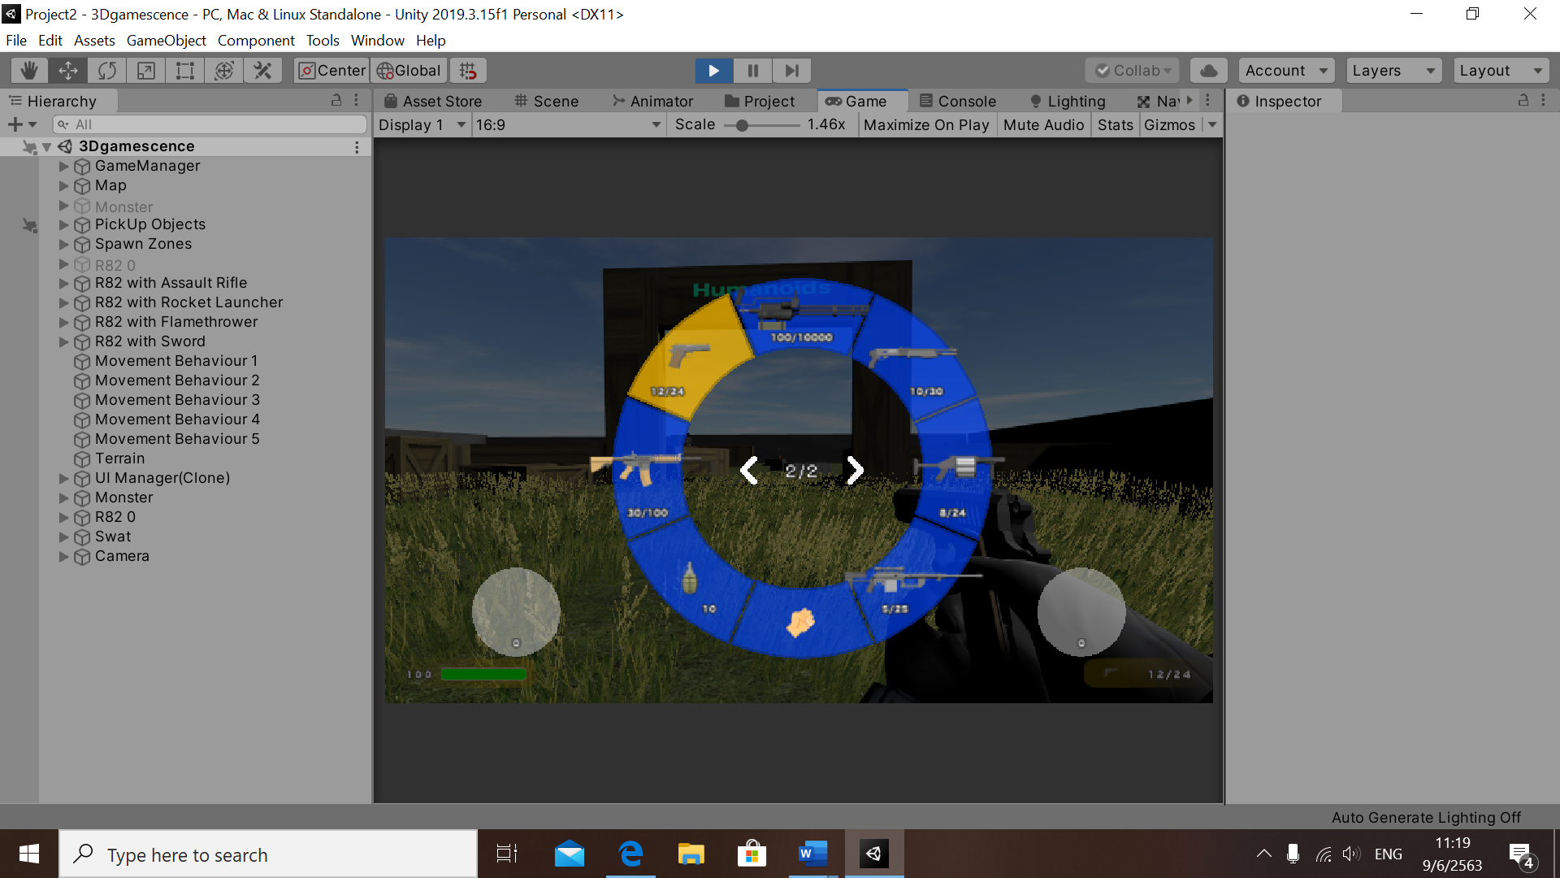

* + **After**

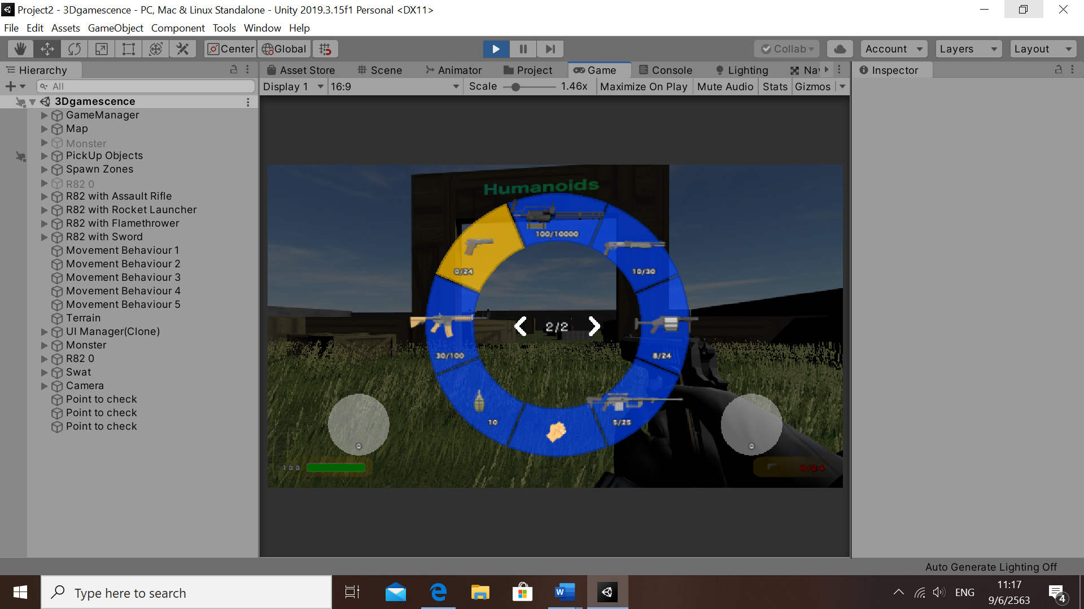

**Checkpoint 6**: Enemy to attack player by any of your design mechanics – This enemy should seek player or has aggo range

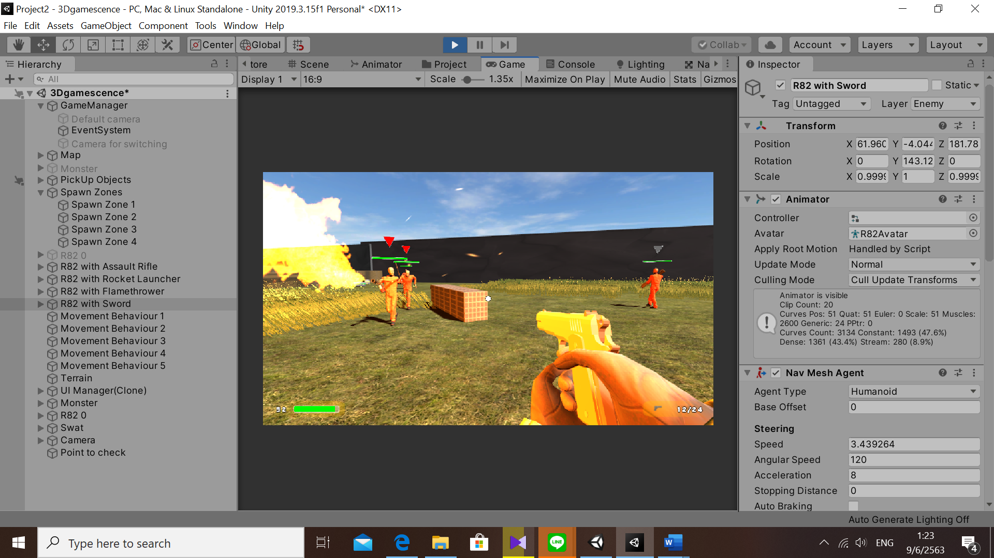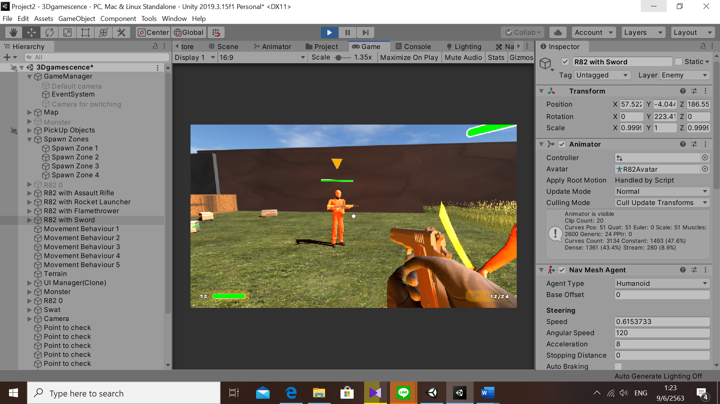

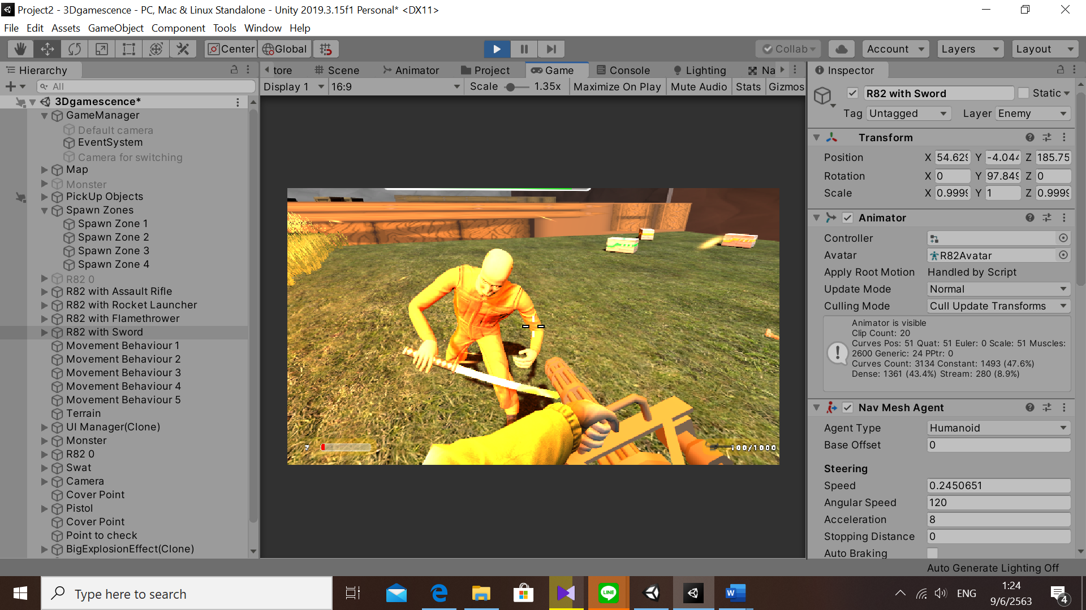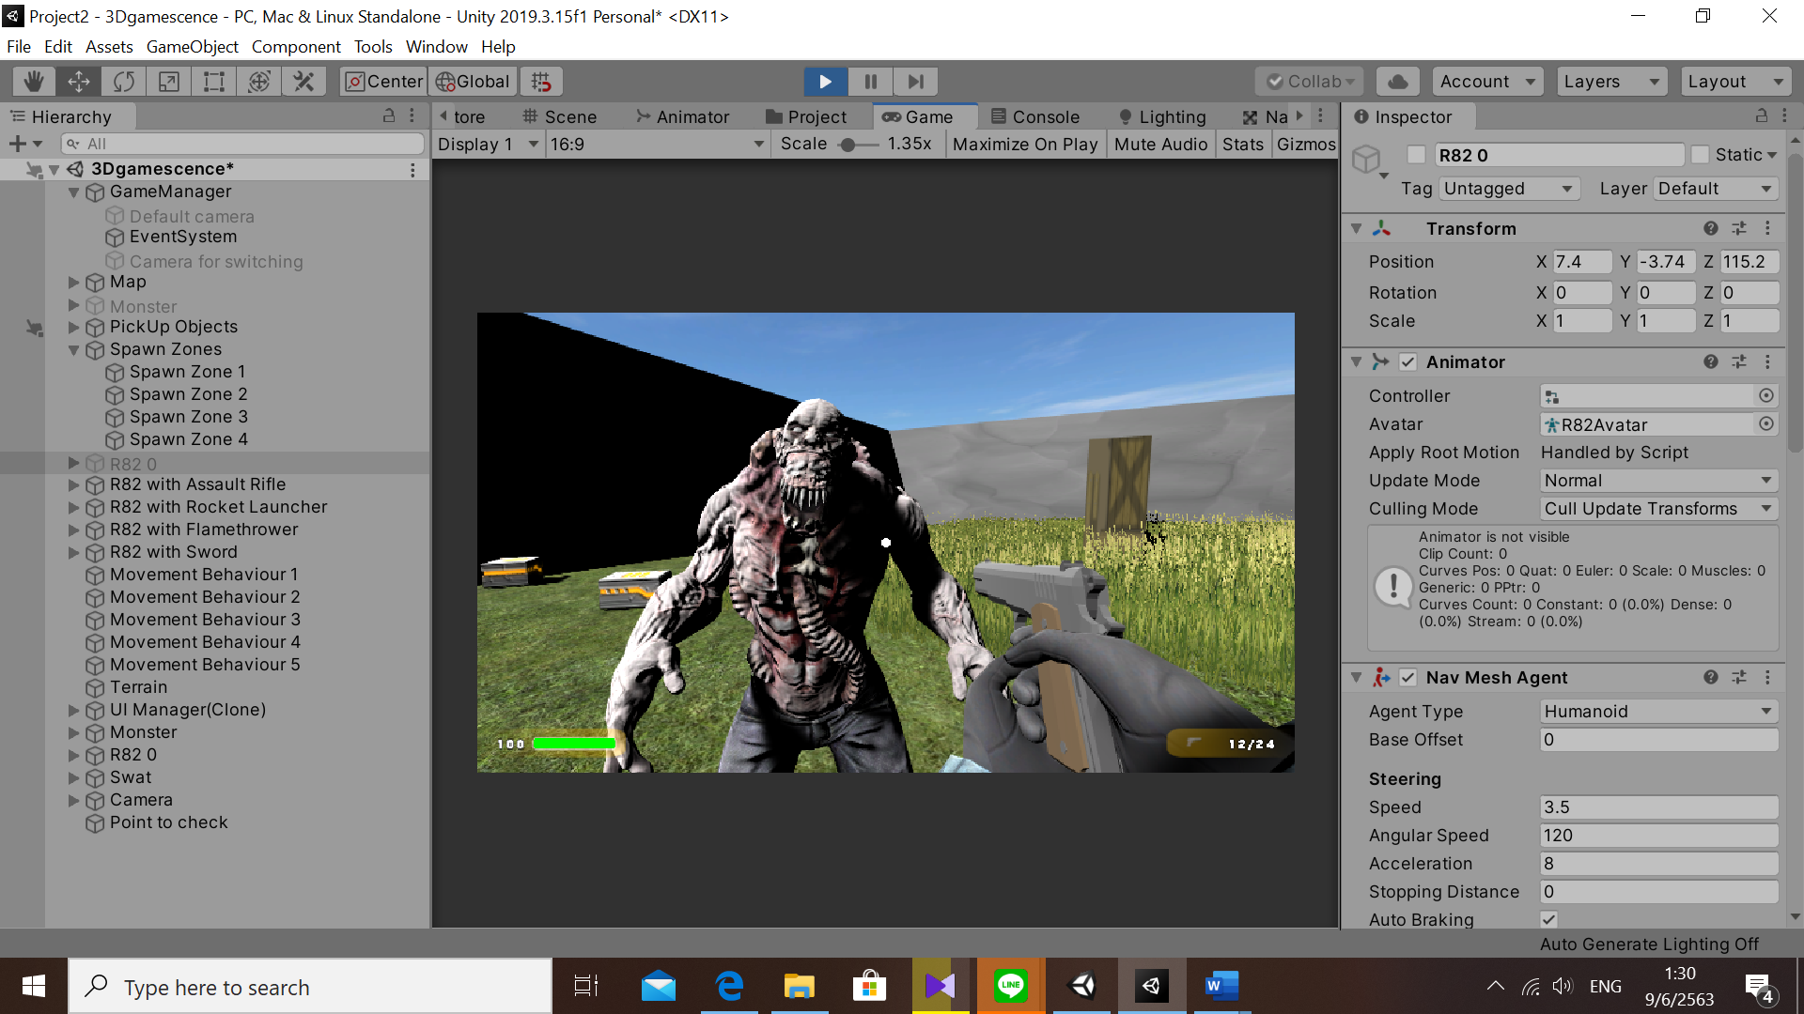

**Checkpoint 7**: Button to trigger player attack(Depending on whatever player is holding)

* + Using right click to aim
  + Using left click to fire the gun and weapon.

**Checkpoint 8:** Health System is required

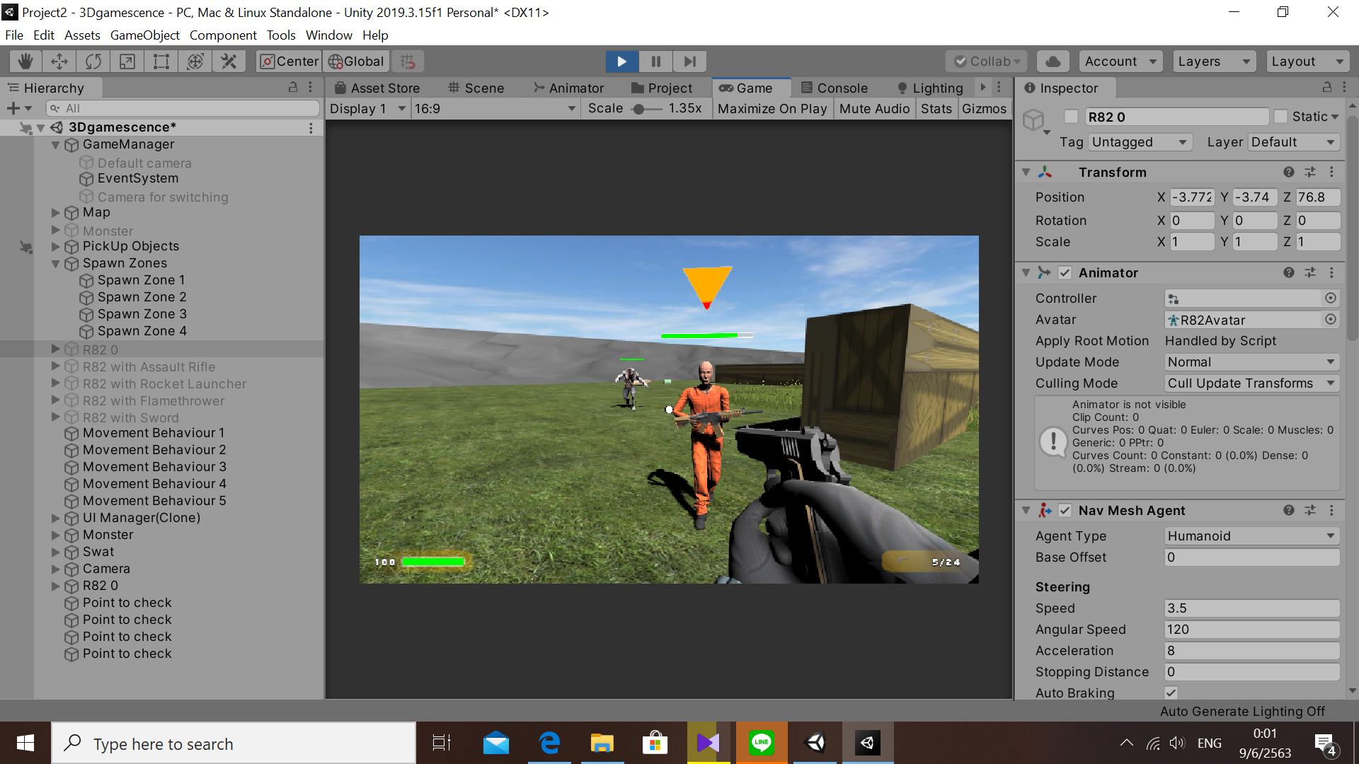

**Checkpoint 9:** Player is required to have a simple primitive model to represent its shape during session

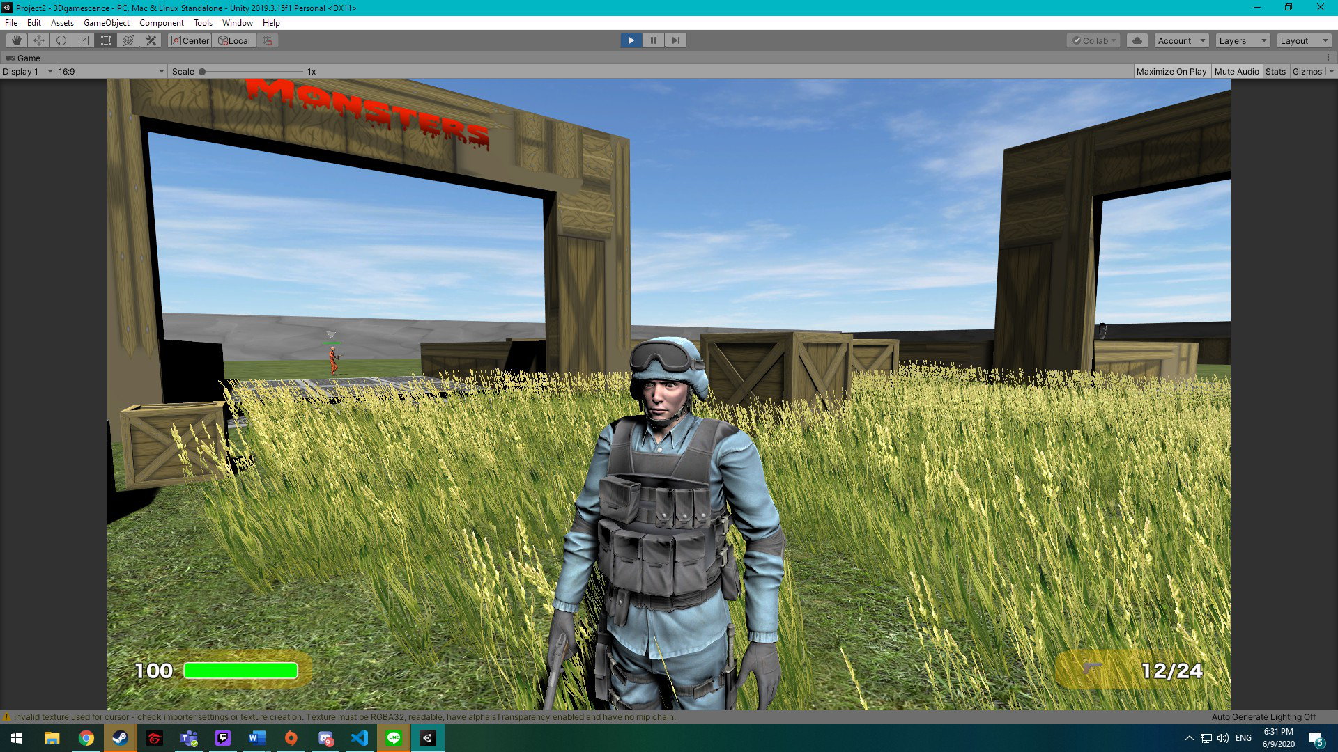

**OPTIONAL :**

**OPTIONAL 1 : HP Bar (Level E:HP-BAR as image)**



**OPTIONAL 2 : Inventory System (Level SS : Variety of Ally)**

